**1.What is Data. Where can we find the data. Types of Data with examples?**

**What is Data?**

**Data** refers to raw, unorganized facts, figures, or information that can be processed to gain insights or make decisions. Data can take various forms, such as numbers, text, images, or audio, and becomes meaningful when analyzed or structured.

**Where Can We Find Data?**

Data can be found in various sources, including:

1. **Primary Sources**:
   * Surveys
   * Experiments
   * Observations
   * Interviews
2. **Secondary Sources**:
   * Government reports (e.g., census data)
   * Research articles
   * Databases (e.g., Google Dataset Search, Kaggle, World Bank data)
3. **Public and Open Data**:
   * Websites like Data.gov, European Data Portal
   * APIs (e.g., Twitter API, OpenWeather API)
4. **Corporate and Organizational Data**:
   * Customer databases
   * Transaction records
   * Social media analytics
5. **Sensor Data**:
   * IoT devices
   * Satellites
   * Environmental sensors

**Types of Data with Examples**

Data can be categorized into two main types: **Qualitative** and **Quantitative**, further divided into subtypes.

**1. Qualitative Data:**

* Non-numerical, descriptive data that characterizes properties or qualities.

**Subtypes**:

* **Nominal Data**: Categorical data without a specific order.
  + Examples: Gender (Male/Female), Eye color (Blue, Brown, Green)
* **Ordinal Data**: Categorical data with a meaningful order but no consistent difference between values.
  + Examples: Education levels (High school, Bachelor’s, Master’s), Customer satisfaction ratings (Poor, Good, Excellent)

**2. Quantitative Data:**

* Numerical data that can be measured or counted.

**Subtypes**:

* **Discrete Data**: Countable, distinct values.
  + Examples: Number of students in a class, Number of cars in a parking lot.
* **Continuous Data**: Data that can take any value within a range.
  + Examples: Weight (70.5 kg), Temperature (36.6°C), Time (2.45 seconds)

**Example Comparison Table:**

| **Data Type** | **Subtype** | **Example** |
| --- | --- | --- |
| Qualitative | Nominal | Hair Color (Black, Blonde) |
| Qualitative | Ordinal | T-shirt Size (S, M, L) |
| Quantitative | Discrete | Number of Siblings (2, 3) |
| Quantitative | Continuous | Height (5.9 ft, 6.1 ft) |

By understanding these types, you can effectively organize and analyze data for insights.

**2.What is Data Wrangling.Expalin the steps of Data Wrangling?**

**What is Data Wrangling?**

**Data Wrangling**, also known as **data munging**, is the process of cleaning, transforming, and organizing raw data into a format suitable for analysis. It involves taking messy, unstructured data and converting it into a structured, usable form. This is a critical step in any data analysis pipeline, as the quality of the data directly impacts the results.

**Steps of Data Wrangling**

1. **Understanding the Data**  
   Before manipulating the data, you need to understand its structure, content, and purpose.
   * **What to do:**
     + Examine the data source.
     + Identify data types, patterns, and missing values.
     + Understand domain-specific nuances.
   * **Tools:** Basic exploratory functions like head(), info(), describe() in Python (Pandas) or summary statistics in R.
2. **Data Collection**  
   Collect data from multiple sources to create a comprehensive dataset.
   * **What to do:**
     + Gather data from APIs, databases, spreadsheets, or web scraping.
     + Combine disparate sources into one dataset (if needed).
   * **Tools:** Python libraries (e.g., requests, BeautifulSoup), database queries (SQL).
3. **Data Cleaning**  
   Removing or correcting inaccuracies, inconsistencies, or missing values in the dataset.
   * **What to do:**
     + Handle missing data (fill, drop, or interpolate).
     + Remove duplicate entries.
     + Correct data types (e.g., converting strings to dates).
     + Address outliers or erroneous values.
   * **Tools:** Python (Pandas), R, Excel.
4. **Data Transformation**  
   Changing the structure of the data to make it more suitable for analysis.
   * **What to do:**
     + Normalize or standardize values.
     + Encode categorical variables (e.g., one-hot encoding).
     + Create new features or variables.
     + Reshape data (pivot tables, melting, etc.).
   * **Tools:** Python (scikit-learn, Pandas), Excel.
5. **Data Integration**  
   Combining data from different sources or datasets into one coherent dataset.
   * **What to do:**
     + Merge or join datasets based on common keys.
     + Ensure consistency in naming conventions and units.
   * **Tools:** Python (merge or concat in Pandas), SQL joins.
6. **Data Reduction**  
   Streamlining the data to focus on relevant features while reducing noise.
   * **What to do:**
     + Remove irrelevant columns or rows.
     + Perform dimensionality reduction (e.g., PCA).
   * **Tools:** Python (scikit-learn), R.
7. **Data Validation**  
   Ensuring the data is accurate, consistent, and ready for analysis.
   * **What to do:**
     + Check for logical inconsistencies (e.g., negative ages).
     + Verify data transformations.
   * **Tools:** Python (data validation frameworks like Great Expectations).
8. **Storing the Data**  
   Save the cleaned and processed data for analysis or sharing.
   * **What to do:**
     + Save data in appropriate formats (CSV, JSON, database).
     + Document the cleaning and wrangling process for reproducibility.
   * **Tools:** Python (to_csv, to_sql in Pandas), databases.

**Summary of Steps in Order**

1. **Understanding the Data**
2. **Data Collection**
3. **Data Cleaning**
4. **Data Transformation**
5. **Data Integration**
6. **Data Reduction**
7. **Data Validation**
8. **Storing the Data**

By following these steps, data wrangling ensures that your data is of high quality, well-structured, and primed for insightful analysis

**3.Explain Normalization & Standardization, Formatting with an Examples?**

**Normalization and Standardization**

Both normalization and standardization are techniques used in data preprocessing to adjust the scale of numerical data so that it can be used effectively in machine learning models or statistical analyses.

**1. Normalization**

Normalization rescales the values of a numerical feature to a range, usually **[0, 1]**. It ensures that the values are proportionally scaled relative to their minimum and maximum values.

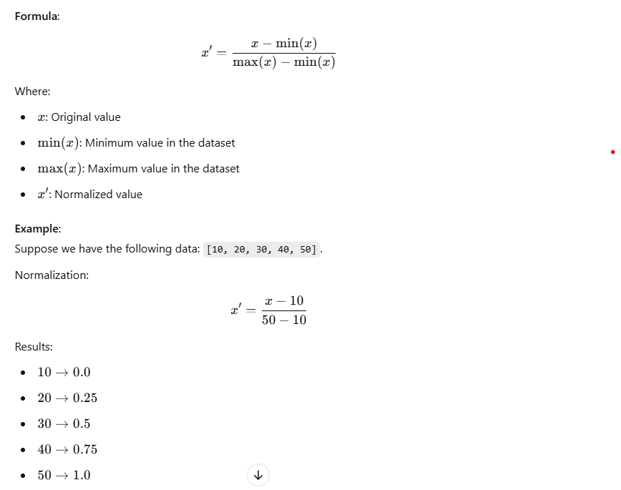

**Use Case**:  
Normalization is preferred when the dataset does **not** follow a normal distribution and when you need values within a specific range, such as in neural networks or distance-based models like K-Nearest Neighbors (KNN).

**2. Standardization**

Standardization rescales the data to have a **mean of 0** and a **standard deviation of 1**. This process converts data into a standard normal distribution (Gaussian) with a bell curve.

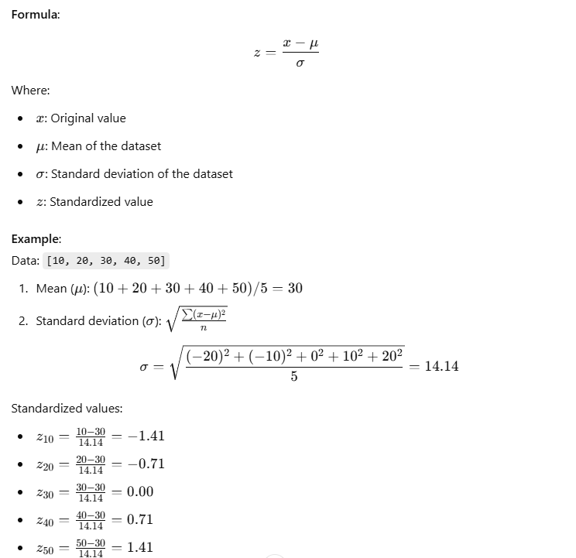

**Use Case**:  
Standardization is commonly used when data follows a normal distribution and is critical in algorithms like SVM, Logistic Regression, or PCA, which assume the input features are standardized.

**3. Formatting**

Formatting involves changing the structure or representation of data to ensure consistency. This can include adjusting numerical formats, dates, or text data.

**Example 1: Formatting Numbers**

* Convert numbers into consistent decimal places:
  + Input: [1, 2.5, 3.14567]
  + Output: [1.00, 2.50, 3.15]

**Example 2: Formatting Dates**

* Transform date formats to a standard format (e.g., YYYY-MM-DD):
  + Input: ["12/25/2024", "25-Dec-2024"]
  + Output: ["2024-12-25", "2024-12-25"]

**Example 3: Text Formatting**

* Standardize text to lowercase for consistency:
  + Input: ["Cat", "cAt", "DOG"]
  + Output: ["cat", "cat", "dog"]

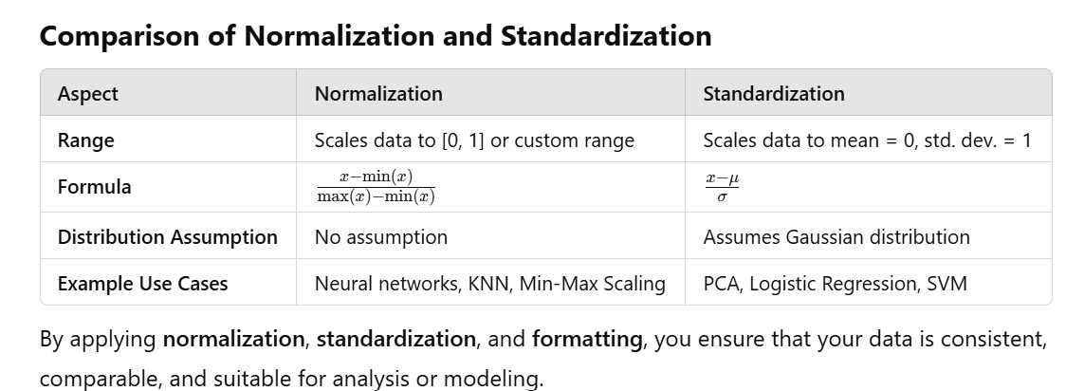

**4.Expalin the steps to create your first visualizations in tableau?**

**Steps to Create Your First Visualization in Tableau**

Creating a visualization in Tableau is straightforward and user-friendly. Tableau is a powerful data visualization tool that allows you to create interactive and insightful dashboards. Here are the steps to create your first visualization:

**Step 1: Install and Open Tableau**

1. Download and install Tableau Desktop or use Tableau Public (a free version).
2. Launch the Tableau application and sign in with your account.

**Step 2: Connect to Your Data**

1. **Click on "Connect"** on the start page.
   * Choose the data source type:
     + File-based: Excel, CSV, or JSON
     + Server-based: SQL, Google Sheets, or other databases
2. Browse and select your dataset.
3. Tableau will load the data and display a preview of the dataset.

**Step 3: Prepare and Explore the Data**

1. Review the data fields (dimensions and measures) in the Data Pane on the left.
   * **Dimensions**: Qualitative data (e.g., names, categories).
   * **Measures**: Quantitative data (e.g., sales, profits).
2. Check for missing or incorrect values. Use Tableau's "Data Interpreter" to clean the dataset if necessary.

**Step 4: Create Your First Worksheet**

1. **Click on "Sheet 1"** at the bottom of the screen.
2. The workspace will have:
   * **Columns and Rows Shelves**: Where you drag fields to define the axes.
   * **Marks Card**: Controls the type of visualization and style.
   * **Data Pane**: Lists all available fields.
   * **View Pane**: Displays your visualization.

**Step 5: Build the Visualization**

1. Drag a field to the **Columns Shelf** (e.g., Month for time).
2. Drag a field to the **Rows Shelf** (e.g., Sales for values).
3. Tableau will automatically create a visualization (e.g., Line Chart for time series).

**Step 6: Customize the Visualization**

1. **Change Chart Type**:
   * Use the **Show Me** panel (top-right corner) to switch between chart types (e.g., bar chart, scatter plot, pie chart).
2. **Add Color**:
   * Drag a field (e.g., Category) to the **Color** shelf in the Marks card.
3. **Add Labels**:
   * Drag the Sales field to the **Label** shelf.
4. **Filter Data**:
   * Drag a field to the **Filters Shelf** to refine the data (e.g., filter by year or region).
5. **Sort Data**:
   * Click on an axis or column header to sort ascending or descending.

**Step 7: Add a Dashboard (Optional)**

1. Click on the **Dashboard** tab at the bottom.
2. Drag sheets from the left pane to the dashboard area to combine multiple visualizations.
3. Add interactive elements:
   * Filters
   * Highlighters
   * Actions (linking visualizations)

**Step 8: Save and Share**

1. **Save your work**:
   * Tableau Desktop: Save as .twb (workbook) or .twbx (packaged workbook with data).
   * Tableau Public: Save to Tableau Public to share online.
2. **Export**:
   * Export your visualization as an image, PDF, or interactive file.
3. **Share**:
   * Publish to Tableau Server, Tableau Online, or embed in websites and presentations.

**Example: Creating a Sales Line Chart**

1. Connect to a dataset with Month and Sales columns.
2. Drag Month to **Columns Shelf**.
3. Drag Sales to **Rows Shelf**.
4. Tableau automatically creates a Line Chart.
5. Drag Category to **Color** to differentiate sales by category.
6. Add Sales to **Label** for data points.

**5.What is Tableau.What are the main products of Tableau.Explain the Tableau tool?**

**What is Tableau?**

**Tableau** is a leading data visualization and business intelligence (BI) tool designed to help individuals and organizations analyze, visualize, and share data insights. It transforms raw data into interactive, shareable dashboards and reports, enabling users to make data-driven decisions effectively.

* **Ease of Use**: Tableau's drag-and-drop interface allows even non-technical users to create complex visualizations.
* **Connectivity**: Tableau can connect to various data sources, including Excel, SQL databases, cloud services, and big data platforms.
* **Interactivity**: Users can filter, drill down, and interact with visualizations to explore data dynamically.

**Main Products of Tableau**

Tableau offers a suite of products catering to different needs:

**1. Tableau Desktop**

* **Description**: A standalone application for creating and sharing visualizations.
* **Features**:
  + Drag-and-drop functionality.
  + Advanced analytics and custom calculations.
  + Connects to multiple data sources.
* **Use Case**: Used by analysts and data professionals to build interactive dashboards and reports.

**2. Tableau Online**

* **Description**: A fully hosted, cloud-based version of Tableau Server.
* **Features**:
  + No hardware setup required.
  + Publish and share dashboards in the cloud.
  + Access from anywhere with an internet connection.
* **Use Case**: Ideal for organizations that prefer cloud solutions for sharing and collaboration.

**3. Tableau Server**

* **Description**: An on-premise platform for hosting and sharing Tableau workbooks created in Tableau Desktop.
* **Features**:
  + Centralized management of Tableau content.
  + Collaboration and access control for teams.
  + Real-time data updates.
* **Use Case**: Suitable for large organizations requiring secure, on-premise data sharing.

**4. Tableau Public**

* **Description**: A free version of Tableau for creating and sharing visualizations publicly.
* **Features**:
  + Free to use but only for public data (no sensitive/private data).
  + Users can publish dashboards to Tableau Public’s website.
* **Use Case**: Used by educators, students, and anyone looking to showcase work publicly.

**5. Tableau Prep**

* **Description**: A tool for data cleaning, shaping, and preparing data for analysis.
* **Features**:
  + User-friendly interface for combining, cleaning, and transforming data.
  + Supports data blending and aggregation.
* **Use Case**: Helps prepare messy data for analysis in Tableau Desktop or Server.

**6. Tableau Mobile**

* **Description**: A mobile application for accessing Tableau dashboards on the go.
* **Features**:
  + Optimized for touch-based interactions.
  + Secure access to Tableau Server or Tableau Online.
* **Use Case**: Allows executives and managers to view dashboards anytime, anywhere.

**Explaining the Tableau Tool**

**Key Features of Tableau**

1. **Data Connectivity**:
   * Connects to various data sources like Excel, SQL databases, Google Analytics, AWS, and more.
   * Real-time data integration for up-to-date dashboards.
2. **Drag-and-Drop Interface**:
   * Build visualizations without any programming knowledge.
   * Drag fields into rows and columns to create charts instantly.
3. **Wide Range of Visualization Options**:
   * Create bar charts, line graphs, scatter plots, maps, heatmaps, bubble charts, and more.
   * Use advanced visualizations like Gantt charts, box plots, and waterfall charts.
4. **Dashboard Creation**:
   * Combine multiple visualizations into interactive dashboards.
   * Add filters, tooltips, and actions for better interactivity.
5. **Interactive Analytics**:
   * Drill down into data to explore details.
   * Create calculated fields and use built-in analytics tools for trend analysis, forecasting, and clustering.
6. **Collaboration and Sharing**:
   * Share visualizations via Tableau Server, Online, or Public.
   * Publish dashboards with access controls.
7. **Geospatial Analysis**:
   * Visualize data geographically with built-in map layers.
   * Plot data points on custom or default maps.
8. **Extensibility**:
   * Support for scripting languages like Python (via TabPy) and R for advanced analytics.
   * Integrate Tableau with APIs for embedding dashboards in web applications.

**Why Use Tableau?**

* **User-Friendly**: Intuitive interface, suitable for non-technical users.
* **Interactive**: Enables dynamic exploration of data.
* **Scalable**: Supports small teams to enterprise-wide implementations.
* **Integration**: Works seamlessly with multiple data sources and platforms.
* **Advanced Features**: Offers powerful analytics, forecasting, and AI-driven insights.

By using Tableau, organizations can democratize data analysis, enabling users at all levels to explore and share data insights efficiently.

**6.Illustrate the Tableau Architecture?**

**Tableau Architecture**

The architecture of Tableau is designed to provide efficient and scalable solutions for data visualization and business intelligence. It is a three-tier architecture consisting of the **data layer**, **application layer**, and **presentation layer**.

**1. Tableau Architecture Components**

**A. Data Layer**

This layer handles data connection and retrieval. It connects Tableau to various data sources.

* **Data Connectors**:
  + Tableau can connect to **structured**, **semi-structured**, and **unstructured** data sources.
  + Examples: Relational databases (MySQL, SQL Server), flat files (Excel, CSV), cloud platforms (Google Analytics, AWS).
* **Live Connection**:
  + Connects directly to the data source, querying it in real-time.
  + Suitable for frequently changing data.
* **Extracts**:
  + Tableau creates a snapshot of the data in .hyper format for faster performance.
  + Suitable for offline analysis or performance optimization.

**B. Application Layer**

This layer manages the core Tableau functionalities, including visualization creation, storage, and sharing.

1. **Tableau Desktop**:
   * Used for designing and creating visualizations, dashboards, and reports.
   * Connects to data sources and publishes workbooks to Tableau Server or Tableau Online.
2. **Tableau Server**:
   * Hosts and manages Tableau workbooks and dashboards for collaboration.
   * Offers features like:
     + User authentication
     + Data security
     + Scheduled data refreshes
   * Runs on the organization’s infrastructure.
3. **Tableau Online**:
   * A cloud-hosted version of Tableau Server.
   * Eliminates the need for on-premise infrastructure.
   * Provides similar features as Tableau Server but managed by Tableau.
4. **Data Engine**:
   * Processes and queries data extracts.
   * Optimized for fast performance and large datasets.
5. **VizQL Server**:
   * Converts queries from Tableau into visualizations.
   * It translates user actions (like selecting fields) into database queries and renders the results as charts.
6. **Gateway**:
   * Handles user requests and distributes them to the appropriate Tableau components.
   * Acts as an entry point for Tableau Server or Online.

**C. Presentation Layer**

This layer focuses on interacting with users and displaying visualizations.

1. **Web Browser**:
   * Users can interact with dashboards and reports via a web interface.
   * Accessible on Tableau Online or Tableau Server.
2. **Mobile Devices**:
   * Visualizations can be accessed and interacted with using Tableau Mobile.
   * Optimized for mobile responsiveness.
3. **Shared Dashboards**:
   * Users can embed Tableau dashboards into applications or websites.
   * Integration with APIs enables interactivity.

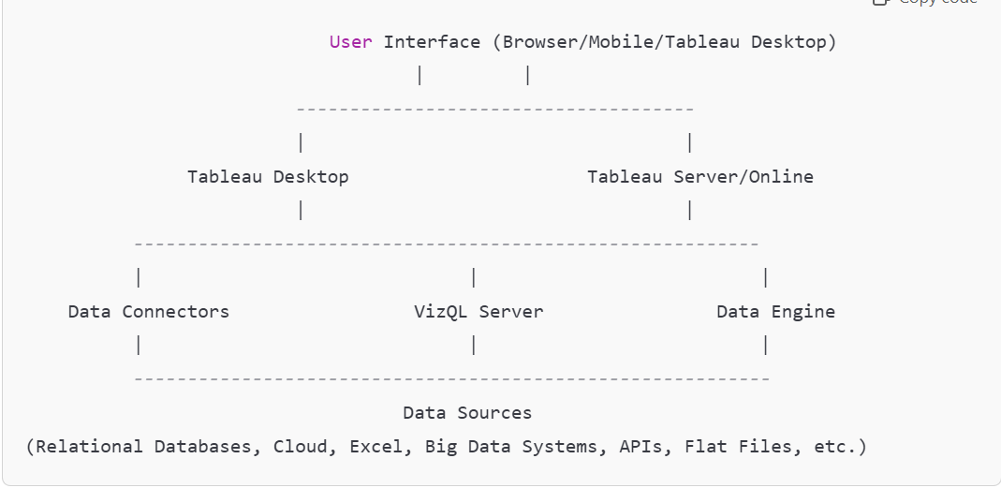

**Tableau Workflow in the Architecture**

1. **Data Connection**:
   * Tableau connects to the data source using live connection or extracts.
   * Users can choose how to handle data updates.
2. **Query Translation (VizQL)**:
   * Tableau uses **VizQL Server** to convert user actions (dragging fields, applying filters) into database queries.
   * The database returns query results.
3. **Data Rendering**:
   * VizQL translates the query results into visualizations.
   * The rendered visualizations are presented on Tableau Desktop, Server, or Online.
4. **Interaction and Sharing**:
   * Users interact with dashboards via Tableau Server, Online, or embedded applications.
   * Dashboards can be shared securely within an organization.

**Key Features of Tableau Architecture**

* **Scalability**: Supports large datasets and concurrent users.
* **Flexibility**: Connects to various data sources and offers live or extract-based analysis.
* **Performance Optimization**: Tableau's data engine and extracts ensure fast visualization rendering.
* **Security**: Tableau Server provides authentication, encryption, and role-based permissions.

**8.What is a Dimension and a Measure in Tableau?**

In Tableau, data fields are categorized as either **Dimensions** or **Measures** to help organize and analyze data effectively. These classifications are based on the type of data and how it is used in visualizations.

**1. Dimensions**

* **Definition**: Dimensions are qualitative, categorical fields that define the granularity of the data. They are typically used to segment, filter, and group data.
* **Purpose**: Dimensions provide context to numerical data (Measures) by breaking it down into categories.
* **Data Types**: String, date, or categorical data.

**Examples**:

* **Customer Information**: Customer Name, Region, Product Category
* **Time Information**: Year, Month, Date
* **Other Categorical Data**: Country, Department

**How Dimensions Are Used**:

* Dimensions are typically placed in the **Rows** or **Columns** shelf in Tableau to categorize data.
* Example:
  + If you have sales data and want to visualize sales by region, the Region field would be a Dimension.

**2. Measures**

* **Definition**: Measures are quantitative, numerical fields that can be aggregated (e.g., summed, averaged). They represent data that can be measured or calculated.
* **Purpose**: Measures provide the values that are analyzed and compared.
* **Data Types**: Numeric data.

**Examples**:

* **Sales Data**: Sales, Profit, Revenue
* **Performance Metrics**: Employee Count, Average Order Value, Discount
* **Other Quantitative Data**: Temperature, Quantity

**How Measures Are Used**:

* Measures are placed in the **Rows**, **Columns**, or **Marks** shelves in Tableau to create visualizations.
* Example:
  + If you want to plot Profit across Region, the Profit field would be a Measure.

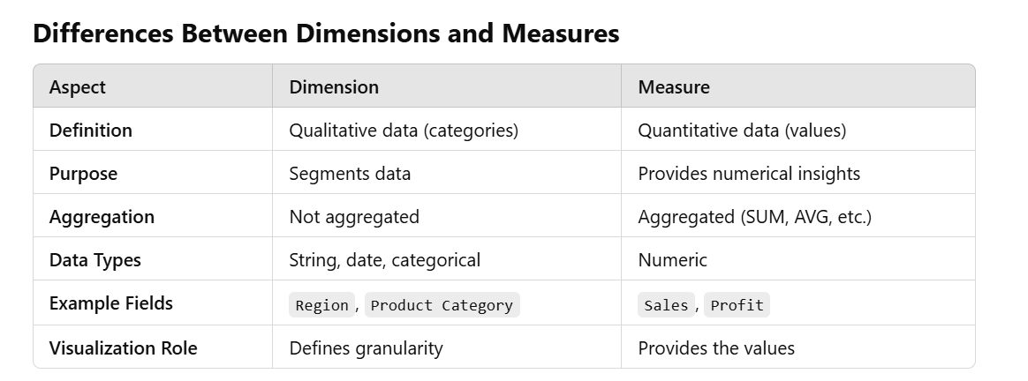

**Examples in Tableau**

**Example 1: Sales by Region**

* **Dimension**: Region
* **Measure**: Sales
* **Visualization**: A bar chart with Region on the X-axis and Sales on the Y-axis.

**Example 2: Monthly Profit Trend**

* **Dimension**: Month
* **Measure**: Profit
* **Visualization**: A line chart with Month on the X-axis and Profit on the Y-axis.

**Example 3: Profit Distribution by Product Category**

* **Dimension**: Product Category
* **Measure**: Profit
* **Visualization**: A pie chart showing the contribution of each category to the total profit.

**How Tableau Treats Dimensions and Measures**

* Tableau automatically categorizes fields as Dimensions or Measures based on their data type and usage.
* **Blue Fields**: Represent Dimensions (Discrete values).
* **Green Fields**: Represent Measures (Continuous values).
* You can convert a Measure to a Dimension (or vice versa) by right-clicking the field and selecting "Convert to Dimension" or "Convert to Measure."

By understanding Dimensions and Measures, you can organize and visualize data more effectively in Tableau.

**9.Differences Between Web Scraping, Indexing, and Sitemap?**

Web scraping, indexing, and sitemaps are all methods related to handling and accessing web data, but they serve different purposes and function in distinct ways. Here's a comparison:

**1. Web Scraping**

* **Definition**:  
  Web scraping is the process of extracting data from websites programmatically. It involves fetching web pages and parsing their HTML structure to retrieve specific information.
* **Purpose**:  
  To gather specific data from websites for analysis, automation, or integration.
* **Key Features**:
  + Fetches targeted information (e.g., prices, reviews, product descriptions).
  + Requires a scraping tool or script (e.g., Python libraries like BeautifulSoup, Scrapy).
  + Can violate website terms of service if not done responsibly.
* **Use Cases**:
  + Price comparison websites.
  + Aggregating data for research (e.g., news, weather).
  + Monitoring competitors.
* **Example**: Extracting product prices from an e-commerce website.

**2. Indexing**

* **Definition**:  
  Indexing is the process used by search engines to catalog and organize web pages for retrieval. When a web crawler visits a website, it analyzes the content and stores it in a structured database called an index.
* **Purpose**:  
  To make web content searchable and quickly retrievable by search engines.
* **Key Features**:
  + Focuses on the structure and relevance of web content.
  + Uses web crawlers (e.g., Googlebot) to discover new pages.
  + Essential for SEO (Search Engine Optimization).
* **Use Cases**:
  + Search engines like Google, Bing, and Yahoo.
  + Providing relevant search results based on user queries.
  + Improving website visibility through better indexing.
* **Example**: A blog post being added to Google’s index so it appears in search results.

**3. Sitemap**

* **Definition**:  
  A sitemap is a file (usually XML) that provides a blueprint of a website’s structure, listing all its important URLs to help search engines understand and index the site efficiently.
* **Purpose**:  
  To inform search engines about the structure of a website and ensure all pages are indexed.
* **Key Features**:
  + Created manually or using tools.
  + Helps search engines crawl and understand website hierarchy.
  + Includes metadata about each URL (e.g., last modified date, priority).
* **Use Cases**:
  + Ensuring all pages of a website are indexed.
  + Helping large or dynamically generated websites improve discoverability.
  + Guiding search engines when pages are not well linked.
* 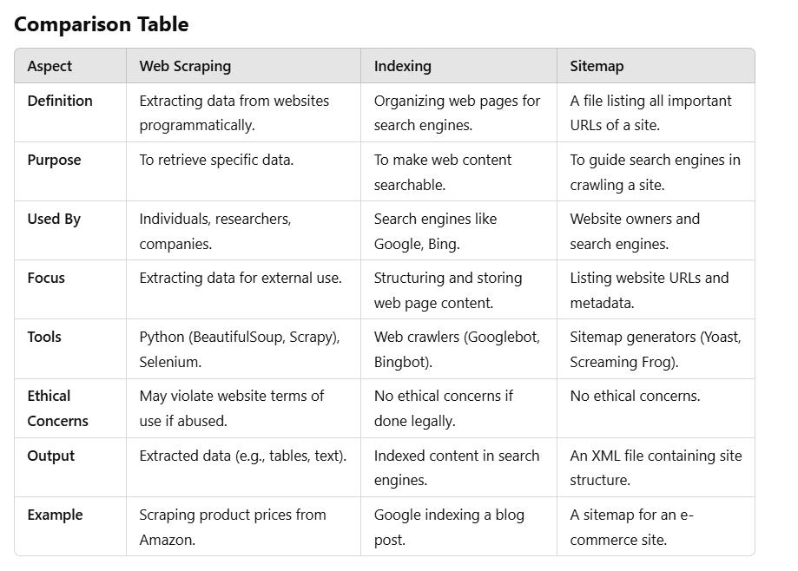**Example**: An XML file listing all URLs of an e-commerce website.

**10.What is outlier. How to detect the outlier with example in tableau?**

**What is an Outlier?**

An **outlier** is a data point that significantly deviates from other observations in a dataset. Outliers can occur due to variability in data, errors, or rare events. They are important to identify because they can:

* Skew statistical analyses.
* Provide insights into anomalies, fraud, or unique phenomena.

**How to Detect Outliers in Tableau**

Tableau provides several methods to detect and visualize outliers effectively. Here are some commonly used approaches:

**1. Using Box Plots**

**Box Plots** are one of the most common ways to detect outliers based on the **Interquartile Range (IQR)**.

* **How it works**:

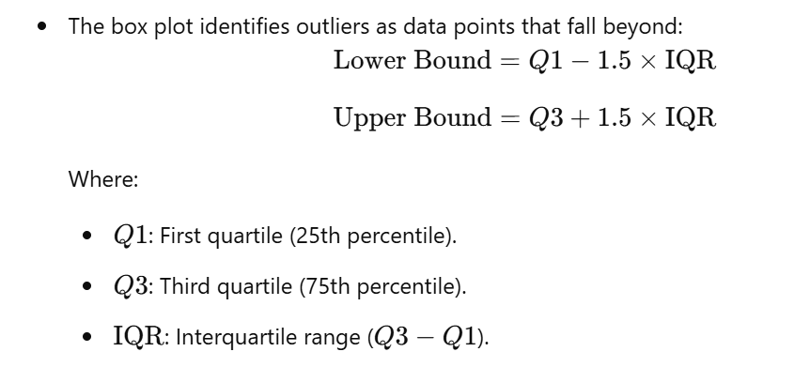

* **Steps in Tableau**:
  + Drag your **numerical field** to the **Rows** shelf.
  + Drag the **dimension** (e.g., Category, Region) to the **Columns** shelf.
  + From the **Analytics pane**, drag **Box Plot** to the view.
  + Tableau automatically highlights outliers as points outside the whiskers.

**2. Using Scatter Plots**

Scatter plots can help identify outliers in two variables' relationships.

* **Steps in Tableau**:
  1. Drag one numerical field (e.g., Sales) to the **X-axis** (Columns shelf).
  2. Drag another numerical field (e.g., Profit) to the **Y-axis** (Rows shelf).
  3. Add a **dimension** (e.g., Region, Product) to the **Color** or **Label** shelf for more context.
  4. Visually identify points that deviate significantly from the cluster of data.

**3. Using Tableau's Built-in Outlier Detection (Clustering)**

Tableau's **clustering algorithm** can help identify outliers by grouping data points into clusters. Points that do not fit well into a cluster may be considered outliers.

* **Steps in Tableau**:
  1. Drag the relevant numerical fields (e.g., Sales, Profit) to the **Columns** and **Rows** shelves.
  2. Go to the **Analytics Pane**.
  3. Drag **Clusters** into the view.
  4. Tableau groups the data into clusters. Points that do not fit well into any cluster can be investigated as potential outliers.

**4. Using Reference Lines and Averages**

Adding reference lines or averages can highlight data points that deviate significantly from typical values.

* **Steps in Tableau**:
  1. Create a chart (e.g., bar chart, scatter plot) with your numerical data.
  2. Drag **Reference Line** from the **Analytics Pane** and drop it on the chart.
  3. Set the line to display **Average**, **Median**, or a fixed threshold.
  4. Identify points that are far from the reference line.

**Example Scenario: Sales Outliers in Tableau**

**Dataset:**

* **Fields**:
  + Region (Dimension)
  + Sales (Measure)

**Task:**

Detect outliers in sales by region.

**Steps:**

1. Drag Region to the **Columns** shelf.
2. Drag Sales to the **Rows** shelf.
3. From the **Analytics Pane**, add a **Box Plot**.
4. Tableau displays a box plot with whiskers for each region. Points beyond the whiskers are flagged as outliers.

**How to Handle Outliers**

Once detected, outliers can be:

* **Removed**: If they result from data entry errors or irrelevant events.
* **Analyzed Separately**: If they represent important anomalies, fraud, or unique occurrences.
* **Transformed**: Use transformations like log scaling to reduce their impact.

By leveraging Tableau's tools, you can easily detect and investigate outliers to gain deeper insights into your data.

What the different types of pdf libraries and usages,what is pdf parser and need of parsing?

**11.Different Types of PDF Libraries and Their Usages?**

PDF libraries are tools and frameworks used to create, manipulate, or extract data from PDF files. Different libraries cater to specific needs such as reading, editing, or extracting text and images.

**1. PDF Creation Libraries**

These libraries allow you to generate PDF files programmatically.

* **Examples**:
  + **FPDF (Python)**:
    - Lightweight and simple to use for creating PDFs.
    - Example Use: Generating invoices or reports.
  + **ReportLab (Python)**:
    - Used for creating complex PDF documents.
    - Example Use: Generating charts and graphics-rich PDFs.
  + **Apache PDFBox (Java)**:
    - Allows PDF generation with text, images, and annotations.
    - Example Use: Custom PDF generation in Java applications.

**2. PDF Manipulation Libraries**

Used for modifying existing PDF files, such as merging, splitting, or adding annotations.

* **Examples**:
  + **PyPDF2 (Python)**:
    - Splits, merges, and rotates PDFs.
    - Example Use: Combining multiple reports into one file.
  + **iText (Java)**:
    - Advanced manipulation like adding metadata, watermarks, and encryption.
    - Example Use: Securing and stamping confidential documents.
  + **PDFKit (Python)**:
    - Converts HTML to PDF.
    - Example Use: Converting web pages to printable PDF format.

**3. PDF Parsing and Extraction Libraries**

Extract text, images, and metadata from PDF files for further analysis.

* **Examples**:
  + **PDFMiner (Python)**:
    - Extracts text and metadata.
    - Example Use: Extracting structured data from financial reports.
  + **PyPDF2 (Python)**:
    - Extracts text and splits PDF pages.
    - Example Use: Extracting specific pages from PDFs.
  + **Tabula (Java/Python)**:
    - Extracts tables from PDFs into structured formats like CSV.
    - Example Use: Extracting data tables from scanned invoices.
  + **PDFPlumber (Python)**:
    - Provides fine-grained control over text and table extraction.
    - Example Use: Parsing complex table layouts in scanned documents.

**4. PDF Viewing Libraries**

Used for rendering and displaying PDF files in applications.

* **Examples**:
  + **PDF.js (JavaScript)**:
    - A web-based PDF viewer by Mozilla.
    - Example Use: Embedding PDF viewing functionality in websites.
  + **MuPDF (C/Python)**:
    - Lightweight library for viewing and rendering PDFs.
    - Example Use: Building a custom PDF viewer in desktop or mobile apps.

**What is a PDF Parser?**

A **PDF Parser** is a tool or software library used to read and extract specific data elements (such as text, images, tables, or metadata) from PDF files. Parsing involves understanding the structure of a PDF file, which can include multiple layers of data such as text streams, vector graphics, and embedded images.

**Why Parsing is Needed?**

Parsing is required because:

1. **Data Accessibility**:
   * PDF files are often unstructured or encoded for visual representation, making it hard to directly analyze their contents.
   * Parsing converts the visual or encoded content into machine-readable formats (e.g., text, CSV, JSON).
2. **Data Analysis**:
   * Extract specific information like tables, text blocks, or figures for analysis.
   * Example: Parsing financial statements to extract revenue details.
3. **Automation**:
   * Automate repetitive tasks such as extracting invoice numbers, customer names, or product details.
   * Example: Processing thousands of invoices in a workflow system.
4. **Search and Retrieval**:
   * Extract metadata or text for indexing and searching within large PDF collections.
   * Example: Searching specific legal clauses in thousands of contract PDFs.
5. **Integration**:
   * Convert PDF content into structured data that can be integrated into databases, APIs, or dashboards.
   * Example: Extracting survey results and populating a database.

**Common Use Cases of PDF Parsing**

1. **Text Extraction**:
   * Extract paragraphs, headings, or keywords for text analysis.
   * Example: Mining keywords from research papers.
2. **Table Extraction**:
   * Extract tabular data for further processing in spreadsheets or databases.
   * Example: Extracting sales data tables from monthly reports.
3. **Image Extraction**:
   * Extract embedded images or graphics for reuse or analysis.
   * Example: Retrieving scanned signatures from documents.
4. **Metadata Extraction**:
   * Extract information like title, author, creation date, and keywords.
   * Example: Archiving and cataloging PDF documents.

Differences between structure data,semi structure data and unstructured data with examples?

**12.Differences Between Structured Data, Semi-Structured Data, and Unstructured Data?**

Data can be classified into three main types based on its organization and ease of processing: **structured**, **semi-structured**, and **unstructured**. Here's a detailed comparison:

**1. Structured Data**

**Definition:**

* Data that is highly organized and stored in predefined formats like rows and columns in relational databases.
* It is easily searchable and can be processed using SQL or similar query languages.

**Characteristics:**

* Fixed schema or structure.
* Easily searchable using indexing and queries.
* Highly organized with clear relationships between entities.

**Examples:**

* **Relational Databases**: Tables with rows and columns (e.g., MySQL, SQL Server).
* **Spreadsheets**: Excel files with consistent rows and columns.
* **Customer Databases**:
  + Fields: Customer ID, Name, Email, Phone.

**Use Cases:**

* Financial systems.
* Customer relationship management (CRM).
* Inventory management.

**Example Table:**

| **Customer ID** | **Name** | **Email** | **Phone** |
| --- | --- | --- | --- |
| 1 | John Doe | john@example.com | 123-456-7890 |
| 2 | Jane Smith | jane@example.com | 987-654-3210 |

**2. Semi-Structured Data**

**Definition:**

* Data that does not have a strict structure but still contains tags, markers, or other organizational elements to define entities and hierarchies.
* Combines characteristics of both structured and unstructured data.

**Characteristics:**

* Flexible schema, allowing variation in structure.
* Partially organized with metadata or tags.
* Cannot be stored in traditional relational databases without transformation.

**Examples:**

* **JSON Files**:

json

{

"CustomerID": 1,

"Name": "John Doe",

"Email": "john@example.com",

"Orders": ["Order1", "Order2"]

}

* **XML Files**:

xml

<customer>

<id>1</id>

<name>John Doe</name>

<email>john@example.com</email>

</customer>

* **NoSQL Databases**:
  + MongoDB stores data in BSON (Binary JSON) format.

**Use Cases:**

* Web data (APIs, logs).
* Social media posts with metadata.
* IoT device data.

**3. Unstructured Data**

**Definition:**

* Data that has no predefined structure or format.
* It is typically stored in its native format and requires advanced processing techniques to extract insights.

**Characteristics:**

* No consistent format or schema.
* Difficult to analyze and query without preprocessing.
* Requires technologies like natural language processing (NLP), image recognition, or machine learning to extract meaningful information.

**Examples:**

* **Text Data**: Emails, articles, books.
* **Media Files**: Images, audio, videos.
* **Social Media Content**: Tweets, Facebook posts.
* **Scanned Documents**: PDFs, handwritten notes.

**Use Cases:**

* Sentiment analysis on social media.
* Image or video recognition.
* 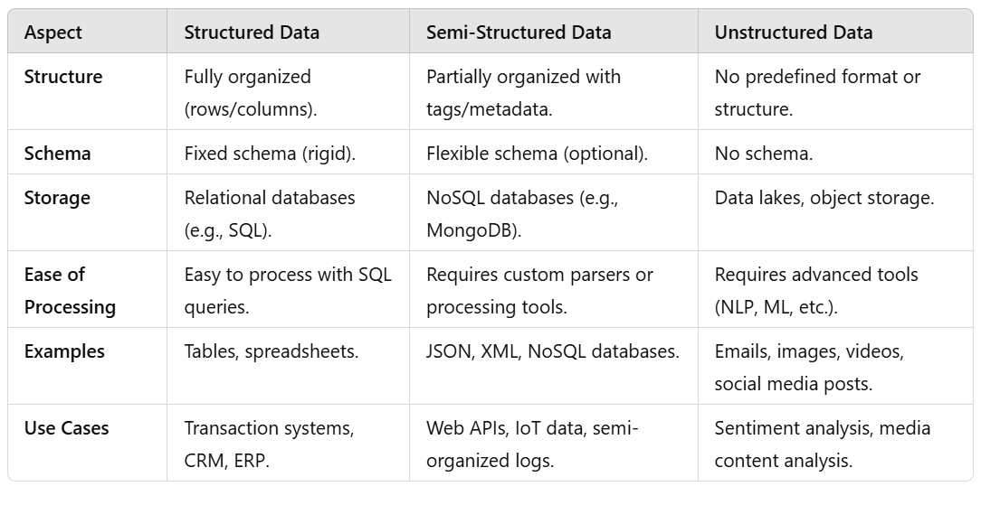Email classification or spam detection.